**Self-review: Filtering data**

In the exercise *Filtering data*, you filtered data in a worksheet. You first downloaded and customized the file *Adventure Works Inventory1.xlsx*. You then filtered the data to find the records that you required.

Your final worksheet should resemble the screenshot:

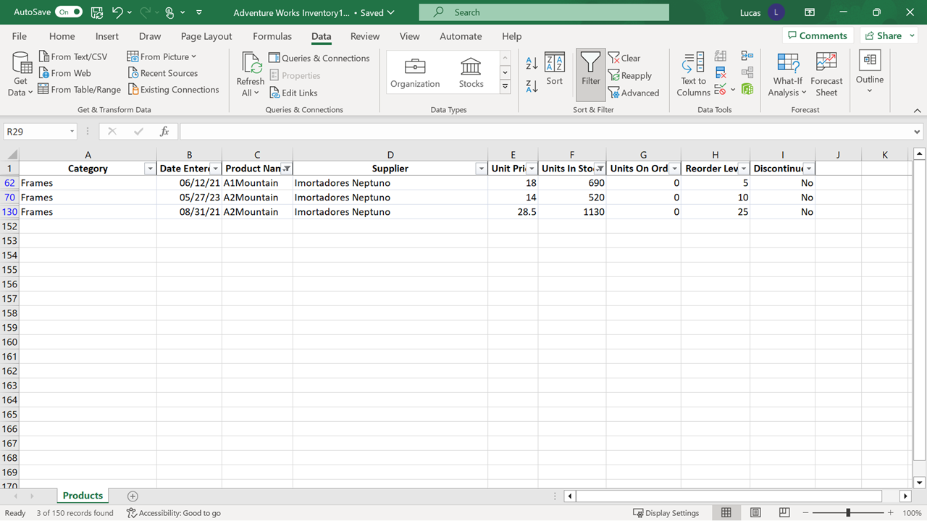

Now it’s time to review your understanding of the tasks you completed by answering the questions that follow. Don’t forget that you can revisit the previous learning items to recap the process steps.

**1.**

Question 1

You have five filters in place on the data in your worksheet. What is the quickest way to remove all filters and restore the full display of data?

Use the **Clear filter from** choice in each filter drop-down.

Use the **Clear** option on the **Data** ribbon.

Use the **Undo** button.

Status: [object Object]

1 point

**2.**

Question 2

You are working with a large block of data. You applied a **filter** but there are still a lot of rows visible. How can you determine how many results you have found?

Check the bottom-right of the Excel Screen.

Check the bottom-left of the Excel screen.

Check the middle of the **status bar.**

Status: [object Object]

1 point

**3.**

Question 3

In the exercise, you selected the **Product Name** **filter** to filter and find all the entries relating to mountain bikes. What were your next steps?

You selected **Text filter** and then **begins** on the sub-menu.

You selected **Text filter** and then **contains** on the sub-menu.

You selected **Text filter** and then **equals** on the sub-menu.

Status: [object Object]

1 point

Coursera Honor Code  [Learn more](https://learner.coursera.help/hc/articles/209818863)

I, **STEVEN DANIEL**, understand that submitting work that isn’t my own may result in permanent failure of this course or deactivation of my Coursera account.*

You must select the checkbox in order to submit the assignment